**9. You configured VLANs 10 and 20 on your switch and assigned ports to each VLAN. However, devices in VLAN 10 cannot communicate with devices in VLAN 20. Troubleshoot the issue.**

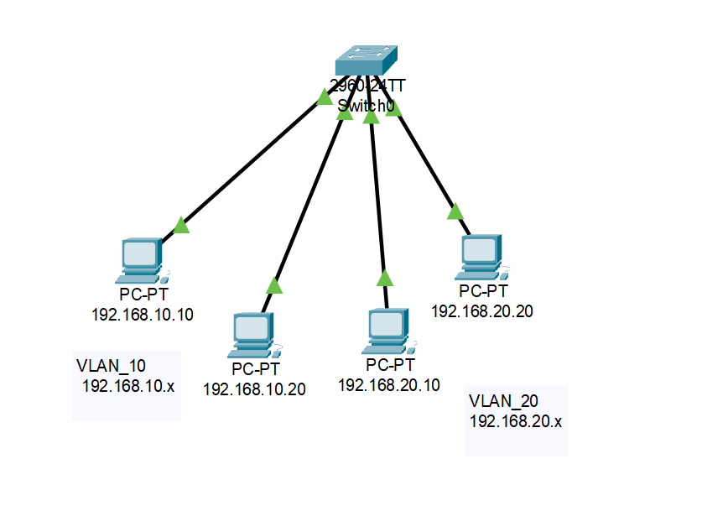

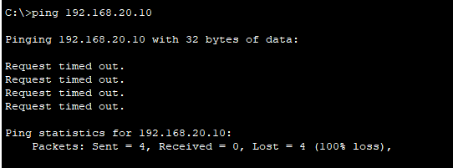

**Fail reason - we have not configured any routing. It can be solved by inter VLAN routing using router.**

**10. Try Inter VLAN routing with Router.**

Configured router in the trunk link to perform the inter VLAN routing.

Created the sub interface for each VLAN and assigned IP address to those sub interfaces to make it act like the default gateway for VLANs respectively.

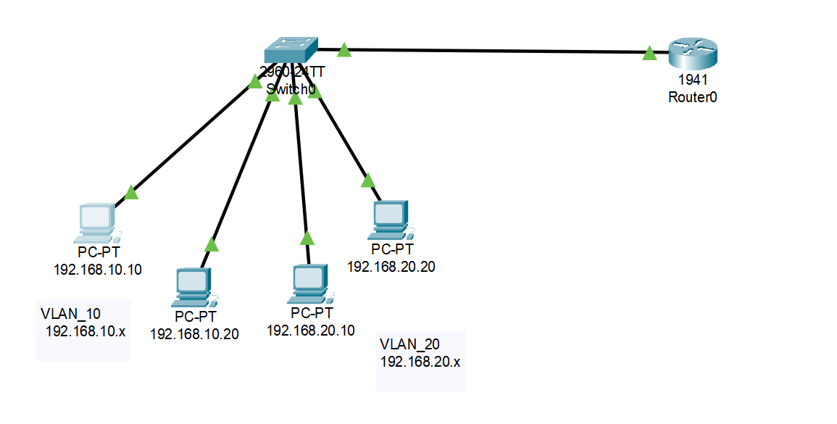

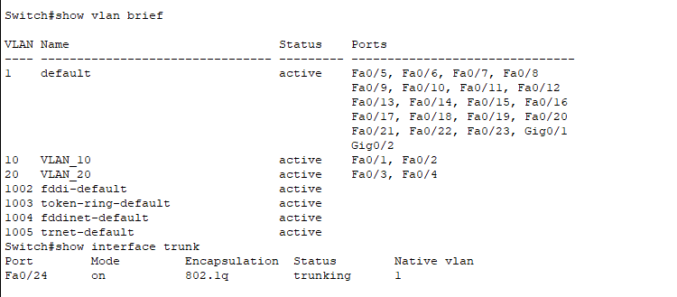

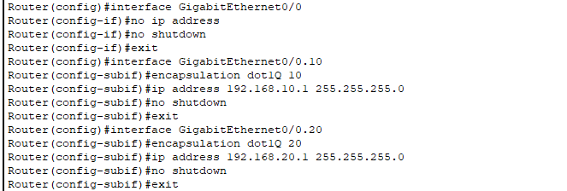

**Pinging from VLAN 20 from VLAN 10:**

**Ping Successful**

